Lane detection by clustering tracks pNEUMA

Aarya Parekh   
Ahmedabad University   
[aarya.p2@ahduni.edu.in](mailto:aarya.p2@ahduni.edu.in)

Diya Patel   
Ahmedabad University   
[diya.p3@ahduni.edu.in](mailto:diya.p3@ahduni.edu.in)

Vatsal Shah   
Ahmedabad University   
[vatsal.s4@ahduni.edu.in](mailto:vatsal.s4@ahduni.edu.in)

Kavyan Savani   
Ahmedabad University   
[kavyan.s@ahduni.edu.in](mailto:kavyan.s@ahduni.edu.in)

***Abstract*—In this project, the goal is to detect lane markings in aerial imagery by clustering vehicle trajectories. This approach provides an alternative solution to traditional lane detection methods, which may be ineffective if the lane markings are faded. The project utilizes trajectories of vehicles across a multi-lane roundabout to detect lanes on the pNEUMA dataset. This paper provides an overview of the methodology used, as well as the results and future scope of the project.**

***Keywords—Lane detection, Clustering, Trajectories, Aerial imagery, Azimuth angle, Traffic monitoring.***

# INTRODUCTION.

Lane detection in aerial imagery through the clustering of vehicle trajectories presents a pioneering approach to overcome challenges posed by faded lane markings. This project, conducted on the pNEUMA dataset, aims to revolutionize traditional lane detection methods by leveraging vehicle movement patterns without explicit road layout information. By utilizing azimuth and acceleration angles along with bounding boxes and Jenks clustering, this methodology offers a promising solution for inferring lane boundaries. The results showcase progress in code development, angle calculations, and visualization, hinting at the potential of this innovative technique for urban traffic monitoring and predictive analysis.

# METHODOLOGY

The methodology for lane detection in aerial imagery using vehicle trajectories focuses on overcoming challenges related to faded lane markings and lack of contextual information in the pNEUMA dataset. To address these challenges, the methodology employs a novel approach that relies on vehicle movement patterns rather than explicit road layout data.

Utilization of Vehicle Trajectories: The core of the methodology revolves around utilizing vehicle trajectories to infer lane boundaries. By analyzing the azimuth angle of each vehicle's trajectory, the general direction of travel is determined. Subsequently, the acceleration angle is incorporated to further refine the lane detection process.

Alternative Approach Development: Given the absence of detailed road layout and boundaries in the dataset, the methodology devises an alternative approach to infer lane structures solely based on vehicle movement patterns. This innovative strategy aims to overcome the limitations posed by incomplete contextual information.

Bounding Boxes and Jenks Clustering: To identify potential lane boundaries effectively, the methodology makes use of bounding boxes and Jenks clustering techniques. By analyzing the distribution of vehicle positions, this approach proves to be reasonably effective in delineating lane boundaries without explicit road layout data. The optimal number of clusters are calculated by computing the k-means and then by finding the elbow point.

In essence, the methodology creatively combines vehicle trajectories, azimuth angles, acceleration angles, bounding boxes, and Jenks clustering to detect lane markings in aerial imagery. This approach not only addresses inherent data limitations but also paves the way for more accurate and efficient lane detection techniques in urban environments.

# DISCUSSIONS

The proposed methodology demonstrates lane detection by utilizing vehicle trajectories. The primary goal of this work was to reproduce the results demonstrated by Barmpounakis et al. [1] for detecting lanes in the pNEUMA dataset. However, our investigation revealed several challenges that had to be overcome in order to achieve this objective.

One of the key challenges we faced was the lack of contextual information in the pNEUMA dataset about the actual road layout and boundaries. To overcome this hurdle, we had to devise an alternative approach to infer the lane structure from the vehicle movement patterns alone. Previously, we relied on the azimuth angle of each vehicle's trajectory to determine the general direction of travel. The Azimuth angle gave us valuable insights into the overall traffic flow, but we still needed to find road boundaries. Therefore, we used acceleration angle instead. In the proposed methodology, we have used bounding boxes and Jenks clustering to identify potential lane boundaries based on the distribution of vehicle positions. This method proved reasonably effective in overcoming previous limitations.

1. RESULTS AND FUTURE WORK

We worked both on the pNeuma and the pNeuma Vision dataset, obtaining different results. The core idea of both the processes was still the same, extract an angle that represents the direction the vehicle is headed in, and then detect the road and lane of the vehicle. For the pNeuma dataset, we used the azimuth angle as defined by Barmpounakis et. al. [1] whereas for the pNeuma Vision dataset, we used the acceleration angle defined by us. For our pNeuma Vision dataset, we tested our method on three different sublocations in the location 10 of the dataset. For each sublocation, we apply the algorithm four times. Out of the four iterations, two focus on 10 frames, whereas the other two focus on 100 frames. Out of each of these two subsets, we filter out motorcycles for one and both motorcycles and taxis for the other. Out of these 12 tests, we observe that the elbow method for k-means clustering estimates the lane clusters accurately for eight tests, over-estimates for four tests. While this is nowhere close to concluding that the methodology has over sixty percent accuracy, we still believe that this is a good approach. Regardless, there are quite a few examples that we would like to discuss that either reveal a lot of information or bring up a lot of questions about the roads in question.

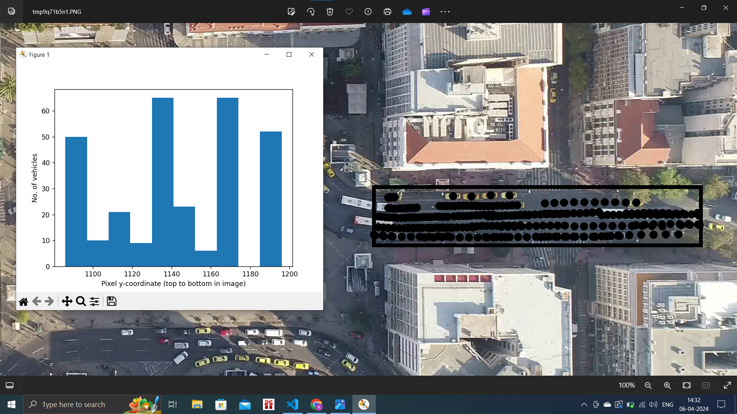

Fig 1. SubLoc-1 Start-Time-0 10-Time-Stamps Filtered-Motorcycle

If one observes keenly, the plots and the dots in fig 1 are quite contradictory. Even though one can easily observe by following the dots that the top-most lane has only a bunch of taxis, whereas the lane below it has much more commotion going on, the plot is seemingly telling a different story. The first lane has many more vehicles listed, almost 50, whereas the second lane does not even have 20.This might be trivial at first glance, but it matters a lot when one tries to study how congestion propagates and whether the number of lanes has any correlation with it. This dilemmatic result is due to the fact that the taxis aren’t moving at all. As there are four stationary taxis, for 10 frames, we already have 40 vehicles marked for that lane. So even though the road has 4 lanes, it is effectively a 3-laned road. This can be easily fixed by accounting for whether the vehicle in the previous frame is either at the same location or is in the immediate vicinity for an extended period of time.

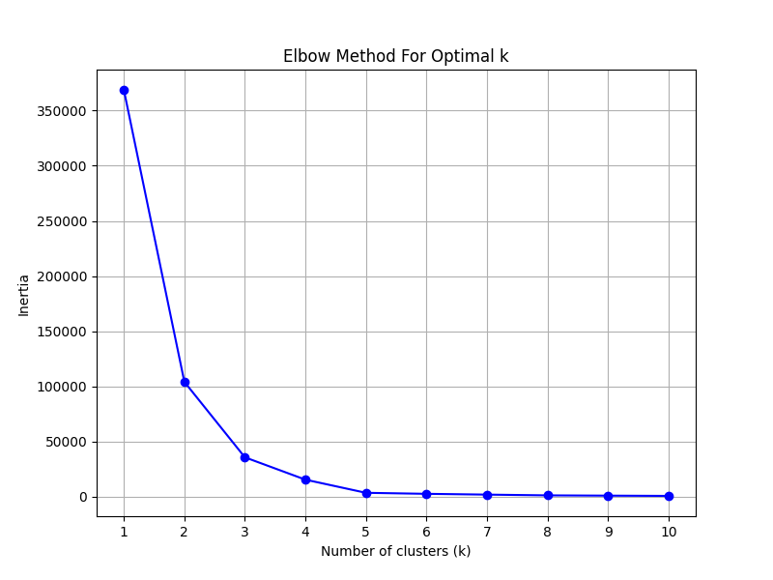

Fig 2. Elbow Method for SubLoc-1 Start-Time-0 10-Time-Stamps Filtered-Motorcycle

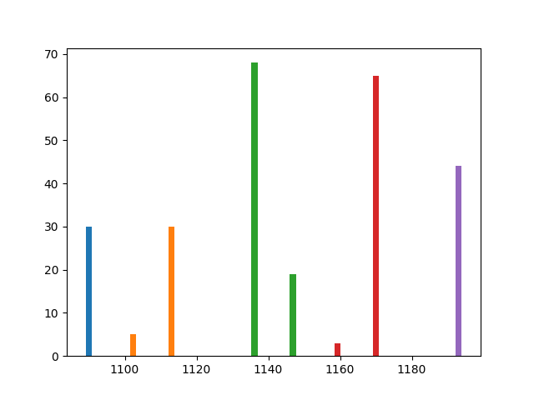

Fig 3. Jenks optimization for SubLoc-1 Start-Time-0 10-Time-Stamps Filtered-Motorcycle

The algorithm can be further improved by implementing the changes discussed for fig 1. One more important issue is that the algorithm can only detect lanes of straight roads. This can potentially be solved by breaking up the road into smaller chunks that act like a straight road and apply the algorithm on the chunks.

1. CONCLUSIONS

The project and the methodology we have used have their limitations as we have broken down the roads into straight subparts since we couldn’t find a way to deal with curved roads. However, using a trajectory-to-equation mapping approach may yield positive results. This means modeling the trajectory of vehicles on the road into a suitable equation on a graph, for example, cubic, logarithmic, or exponential functions, thereby modeling the road closest to that function on the graph and then using a clustering method for that function. All in all, lane detection using the Jenks clustering algorithms with the help of the elbow method for k-means for small pieces of the road yields clear and definitive results. Using the aerial image footage of vehicles can be considered a revolutionary technique to determine lane-specific information in a large-scale urban dataset. The dataset footage we used was from Athens, Greece and the road networks in a European country are much less unorganized than in a country like India. This poses a challenge to implementing this method in Indian road environments but this methodology can be employed in densely populated urban, organized road networks to predict even the most unexpected lane-use behaviors in real life. This also opens future prospects for more advanced methodologies like the trajectory-to-equation to accurately predict lane-specific information using real-time drone monitoring.

1. REFERENCES
2. Barmpounakis, Emmanouil, Guillaume M. Sauvin, and Nikolaos Geroliminis. "Lane detection and lane-changing identification with high-resolution data from a swarm of drones." Transportation research record 2674.7 (2020):pp. 1-15.
3. Azimi, S. M., Fischer, P., Körner, M., & Reinartz, P. (2018). Aerial LaneNet: Lane Marking Semantic Segmentation in Aerial Imagery using Wavelet-Enhanced Cost-sensitive Symmetric Fully Convolutional Neural Networks.pp. 1-4